**11/10/2021 ML SPOT 6 2019103573**

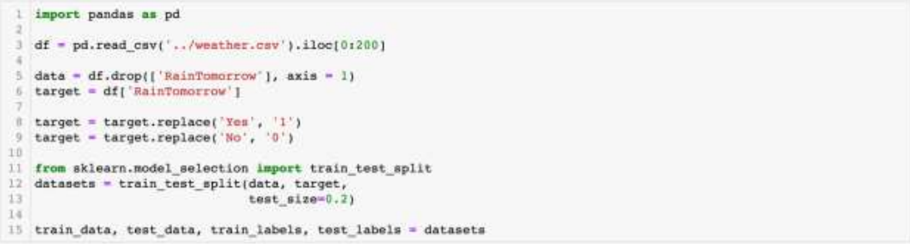**1. Change the number of neurons in the hidden layer and plot the performance for varying number of hidden neurons wrt. the training set for various iterations.**

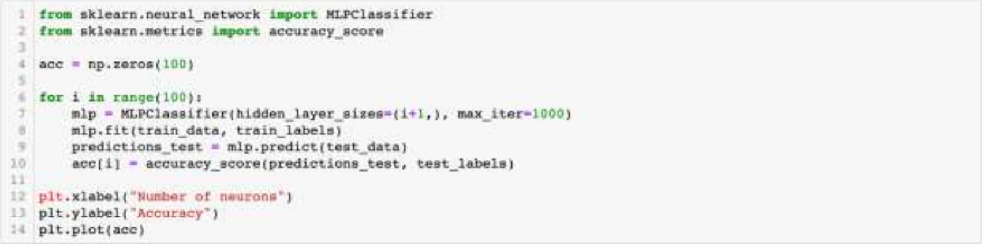

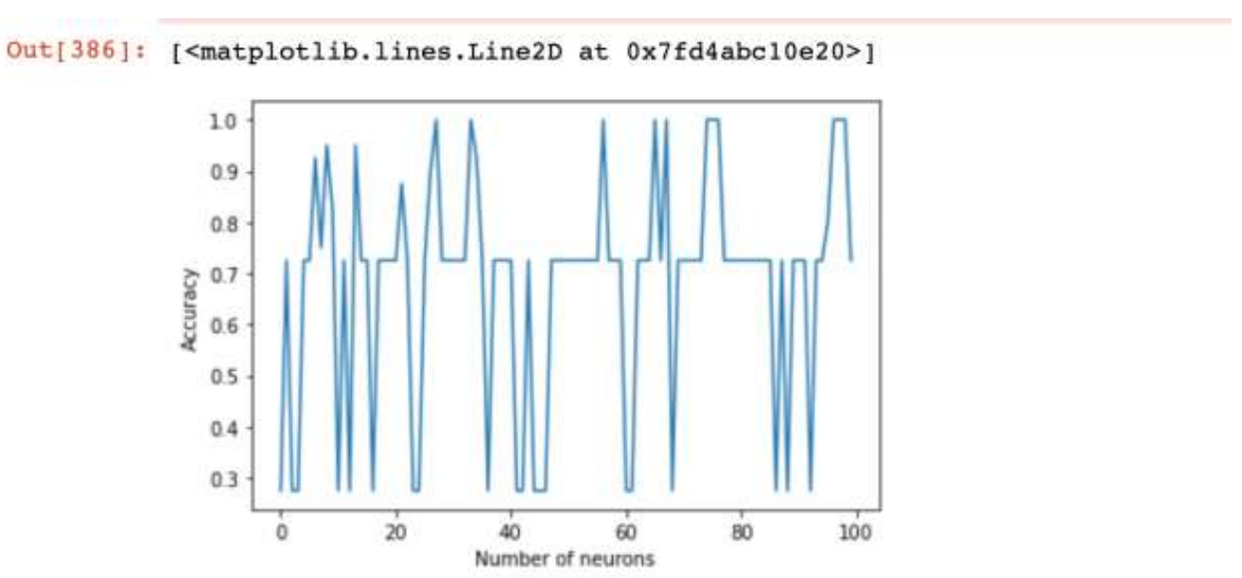

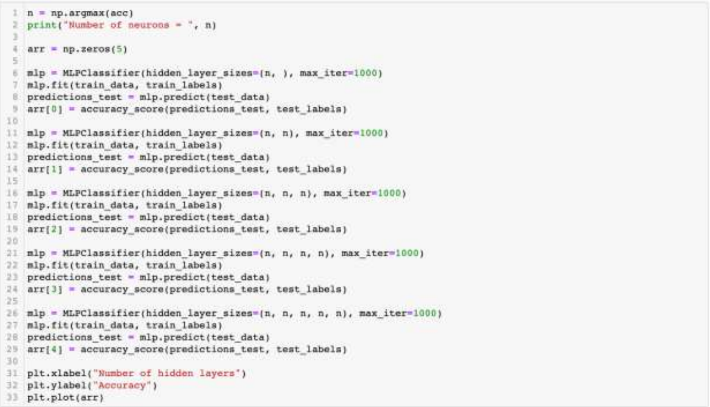**2. Change the number of hidden layers for the number of neurons with best performance from 1 and plot the performance for varying number of hidden neurons wrt. the training set for various iterations.**

